Question 1 (1 marks)
- Determine the solution to both graphs $x-y+5=0$ and
$3x+y-9=0$simultaneously , using the graph below.

Name: | ___________________________________________________ | Date: ___________
 | Year 10 Mathematics – Simultaneous equations  Test 7, 2021  Topic – Algebra | 26  = %

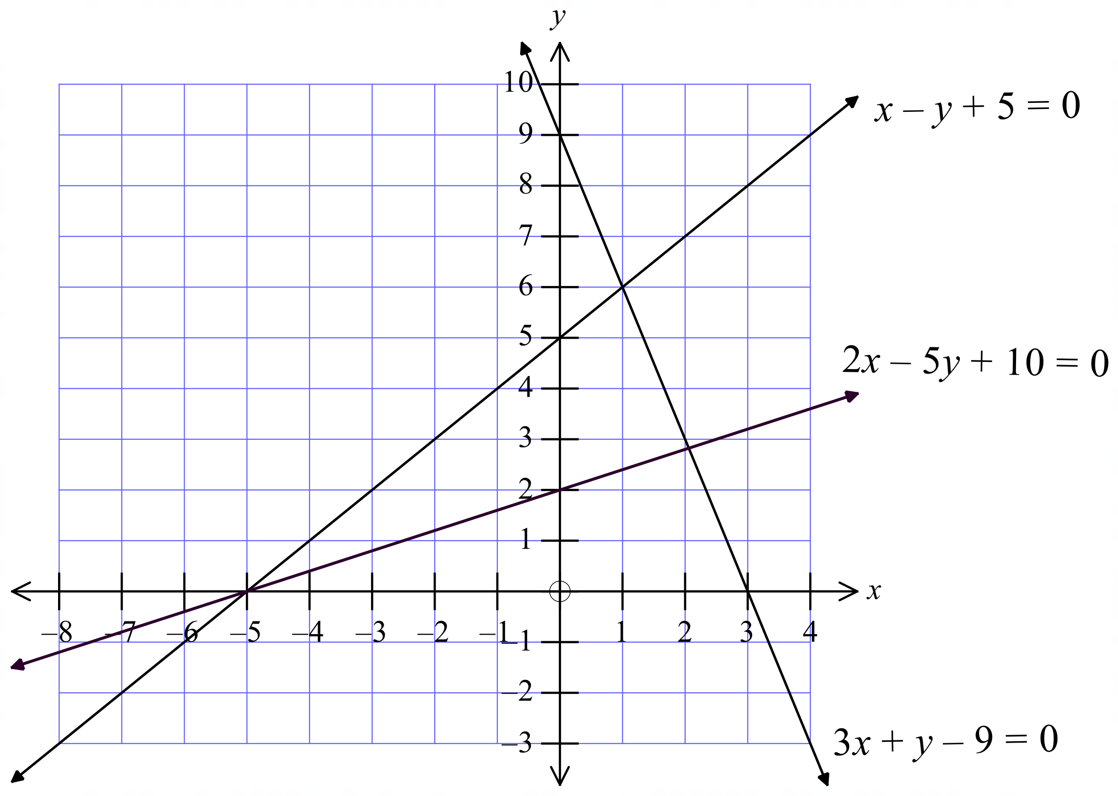

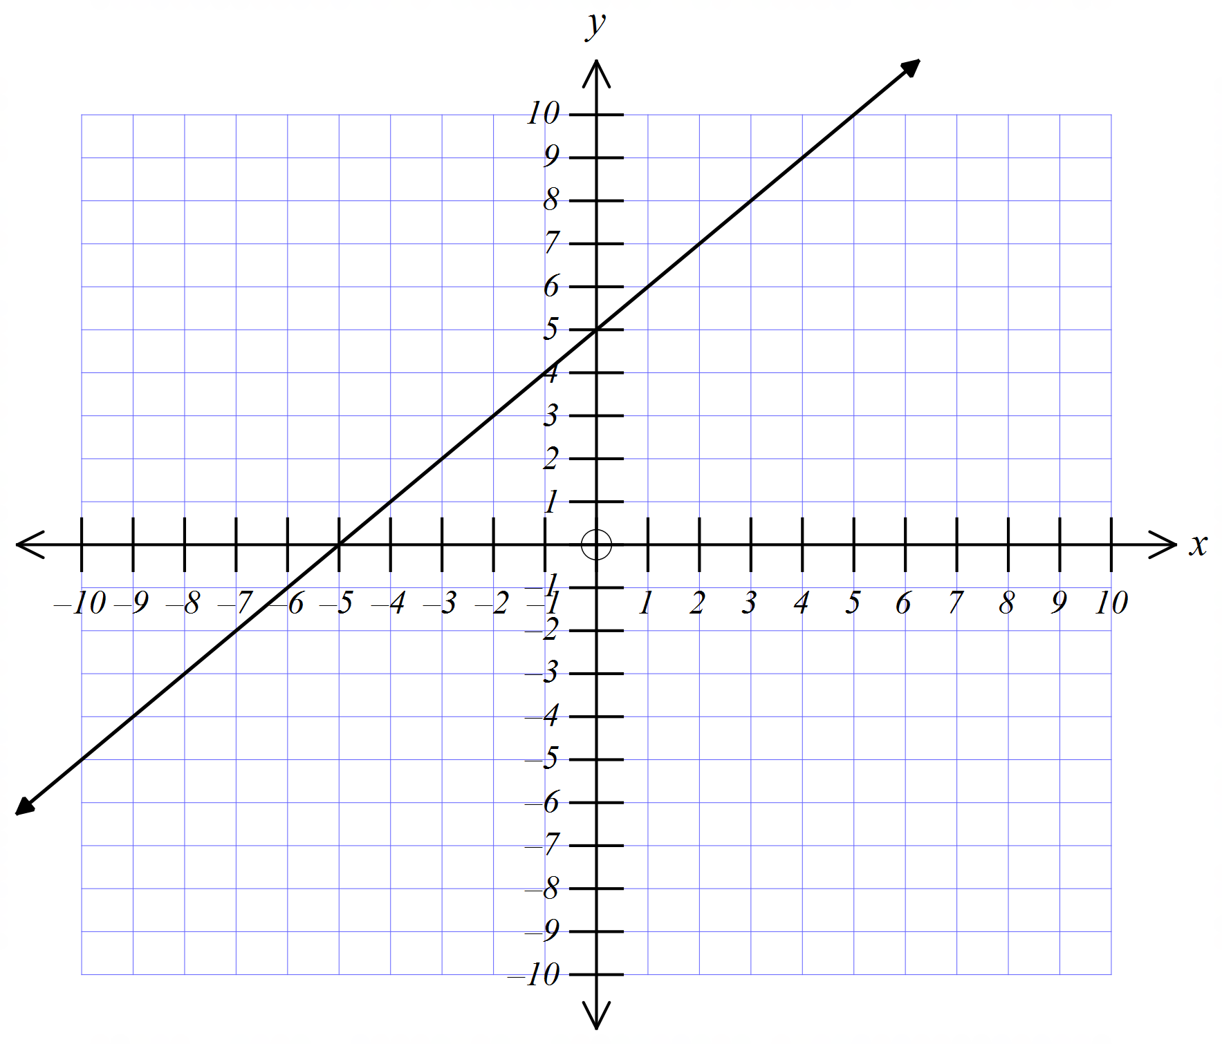Question 2 (6 marks)
The line 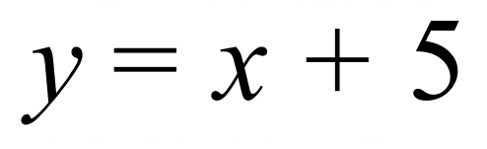 is shown on the graph below.

- Draw the lines $y=-3x+2 and 0=-y+2x+3$
x | -2 | -1 | 0 | 1 | 2
$$y=-3x+2$$
$$0=-y+2x+3$$

- Solve 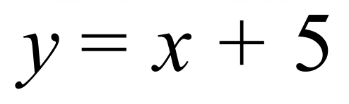 simultaneously with 0 $=-y+2x+3$ using the Point of intersection

- Solve $y=-3x+2$ simultaneously with 0 $=-y+2x+3$ using Algebra Techniques.

Question 3 (5 marks)
Solve the following equations by using the substitution method
$x=4y-2$ and $2x+3y=18$

$2x-y=-10$ and $7x-2y=1$

Question 4 (5 marks)
Solve the following equations by using the elimination method
$x-y=7$ and $3x+y=9$

$-2x+5y=66$and $3x+4y=85$

Question 5 (4 marks)
The sum of two numbers, then divided by 3 is 6. When 4 times the first number is added to 3 times the second number, the result is 62. What are the two numbers?

Question 6 (5 marks)
A Disability service office buys some iPads and Mac book’s. They spend a total of $9800 on 14 devices. The iPads are $450 each, and the Mac Books are $800 each. Determine, with proof, how many Mac books and iPads they purchased?

